German impulses in the development of a Norwegian classical music tradition
by Berit Holth

1
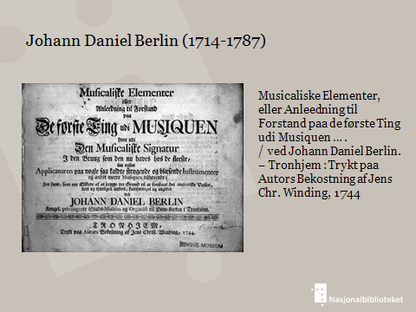2
It is not until the nineteenth century that Norwegian musicians and composers received international fame. Germany was central in this development. German impulses in Norwegian musical activities had already been present long before. In the year 1737, the German musician and composer Johan Daniel Berlin (1714-1787) became town musician in the Norwegian town Trondheim. He published the first textbook in musicology in Denmark-Norway (picture 2).
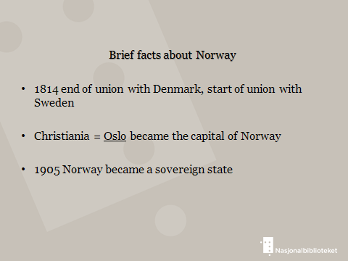3
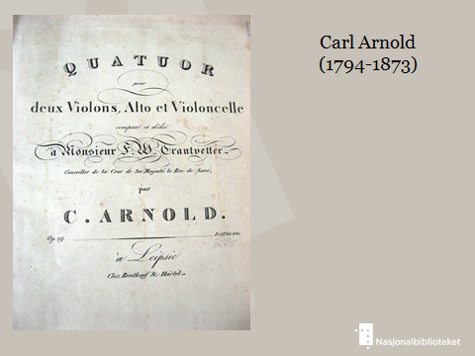4
German musicians and composers who settled in Norway made footprints in Norwegian music life. One of them was Carl Arnold (1794-1873). Many Norwegian students received classical training by Arnold. Arnold was also eager to influence and convince the authorities about the importance of establishing music schools as well as giving scholarships to young musical talents, giving them the ability to go abroad and study (picture 4).
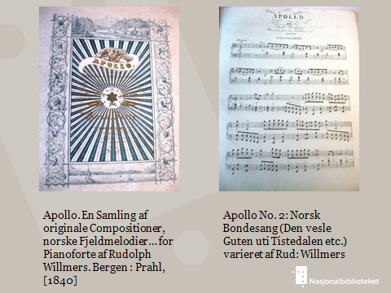5
The German musician and composer Rudolph Willmers (1821-1878) did a concert tour in Norway around 1840. On this occation his variations on Norwegian folktunes were published. This was before it became common for Norwegian composers to do the same (picture 5).
6
A German music ensemble, called Harzverein, entertained in Norway on tour. One of the musicians, Carl Warmuth (1811-1892), settled in Norway. He established the music publishing company Warmuth musikforlag in Christiania (Oslo) in 1843. Warmuth became the most important music publisher in Norway in the second half of the nineteenth century (picture 6). Most of the scores were sent to Germany and printed in Leipzig at C.G. Röder or F.W. Garbrecht. At its height, more than half of the sheet music of the entire world was printed by Leipzig’s music printers (picture 7).
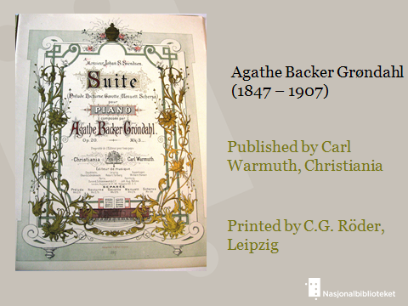7
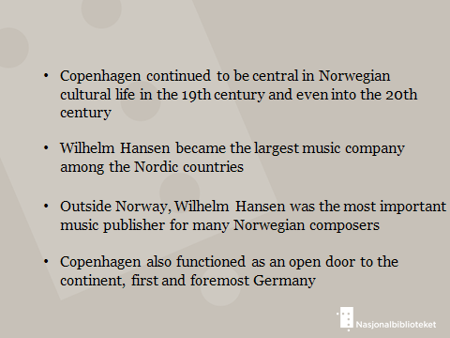8
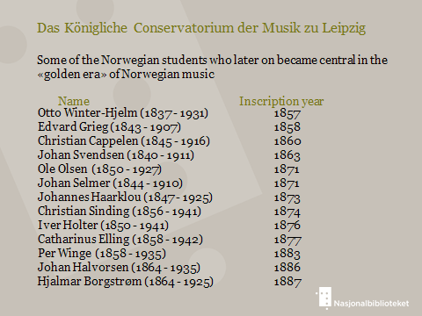9
After the Leipzig Music Conservatory was established in 1843, it became the most popular place to study abroad for Norwegian music students. In the first period of 50 years, the conservatory educated 146 Norwegian students, 93 of these were women (picture 9).
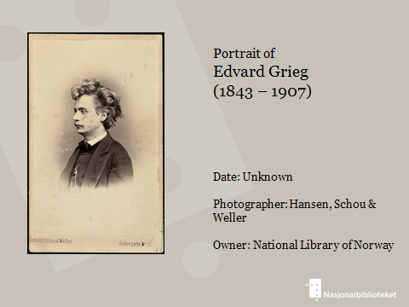10
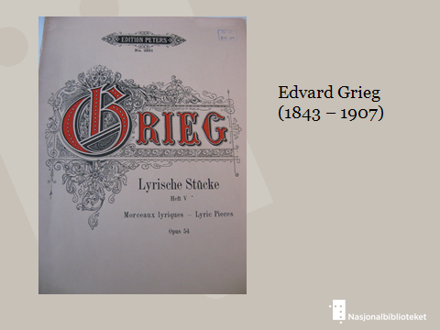11
The Norwegian composers who became famous through Germany were above all Edvard Grieg, Johan Svendsen, Christian Sinding and Johan Selmer. Edvard Grieg (1843-1907) was only 15 years old when he started to study composition at the Leipzig Conservatory. His opus 1 and 2 were published in 1863 by Peters Verlag. Dr. Max Abraham had just become head of Peters, which in time became the main publisher of Grieg’s works. The business relationship between the composer and Max Abraham turned also into friendship. Grieg became the bestselling composer of Peters. In 1889, a Generalvertrag was signed (picture 10-11).
Some of the other well-known Norwegian composers who published music in Germany were:
Johan S. Svendsen (1840-1911) who published many works by Fritzsch (picture 12).

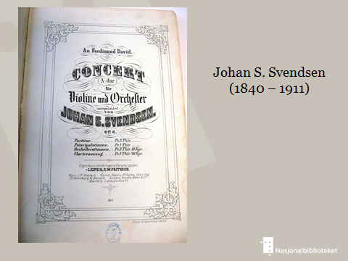12
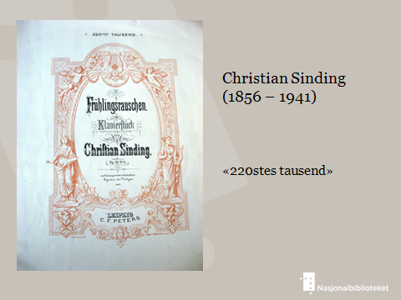13
Christian Sinding (1856-1941) gained entry at Peters at an early stage in his career. In 1896, his piano piece Frühlingsrauschen, or Rustle of spring, was published. This became Peters greatest single hit. Sinding also published many works by Rob Forberg and Breitkopf & Härtel, both in Leipzig, as well as publishers in Berlin, Magdeburg and Mainz (picture 13).
On Grieg’s recommendation, the orchestral work Vasantasena by Johan Halvorsen (1864-1935) was published by Peters (picture 14).
Johan Selmer (1844-1910) wrote 61 opuses altogether. Nearly one half of these works were published by German publishers. These were: Fritzsch, Constantin Wilds Verlag and Siegel, all in Leipzig, and Fritz Schuberth in Hamburg (picture 15).
Some composers also got their works published in Germany on commission, at their own cost. This was partly the case with Gerhard Schjelderup (1864-1935), who published about 30 works in Germany by different publishers in Leipzig, Berlin, Cologne, Dresden and Munich (picture 16).

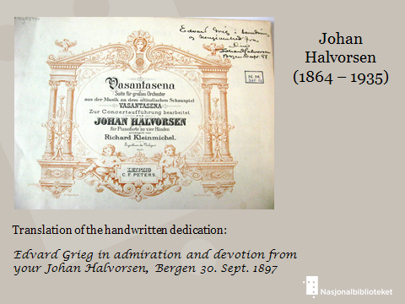14
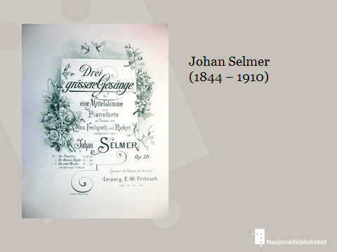15
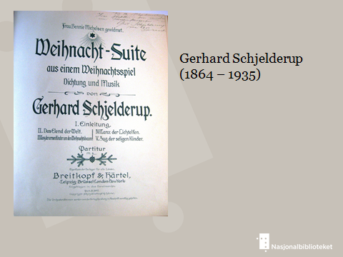16

